Task 8

1. Chat GPT

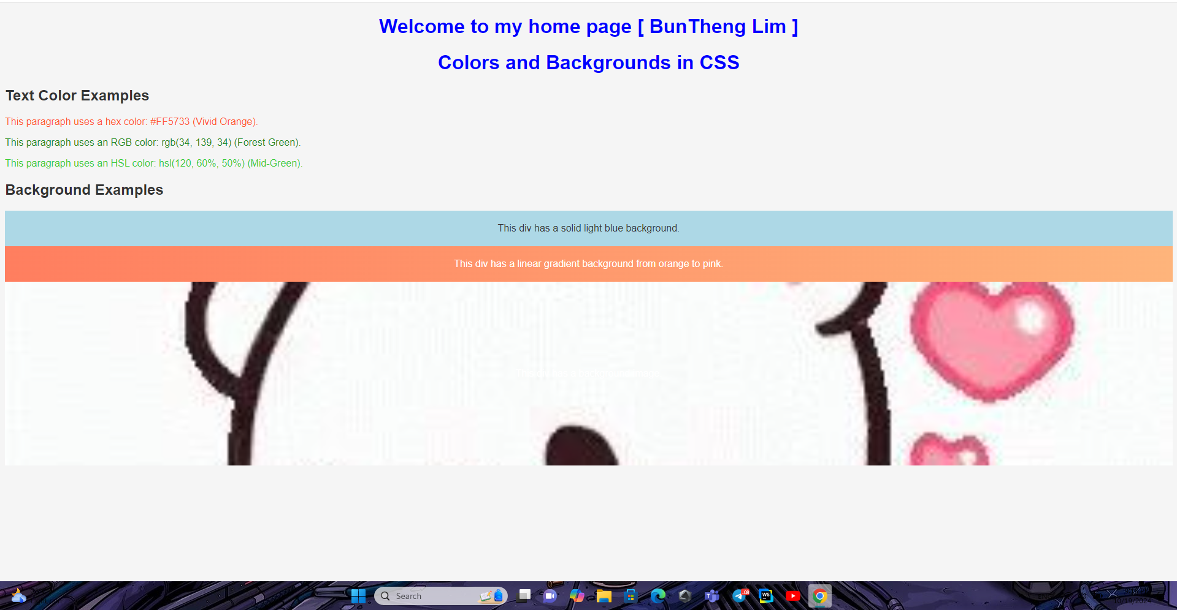

2. Gemini

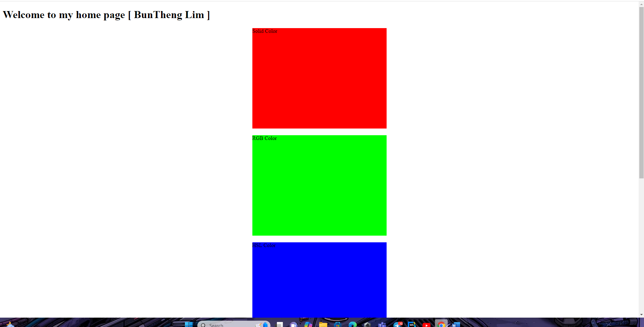

Chat GPT is explain by letter and Gemini explain by box. But Gemini’s explaining is better. One more Chat GPT has the place to add picture but Gemini doesn’t have.